

SMART HEALTH RESPONSE APPLICATION FOR ASSISTING INJURED INDIVIDUALS

A project report submitted in partial fulfilment of the requirement for the award of the degree for
BACHELOR IN INFORMATION TECHNOLOGY

by
Project Team Members
Student name(s) | University ID(s)
Donya Abdullah Suhail | 202308374
Reemas Sami Alhafaf | 202206093
Ola Abdullah Alfaifi | 202306892
Rawan Mosa Alfaifi | 202204023
Asma Zahid | 202208893
Amal Sharif | 202305620
SUPERVISOR

Aisha Al-Sumaili
Jazan University
College of Engineering and Computer Sciences
Department of Computer

(Completion Date:‏19‏/11‏/2025)

DEPARTMENT OF COMPUTER SCIENCE
BACHELOR IN INFORMATION TECHNOLOGY
APPROVAL FOR BINDING OF GRADUATION PROJECT REPORT

GRADUATION PROJECT:
GROUP NUMBER: 655
SESSION:
To be filled in by student
Student name(s): | DONIA SUHAIL, REEMAS ALHAFAF,OLA ALFAIFI,RAWAN ALFAIFI,ASMA ZAHID,AML SHARIF
University ID(s): | 202308374,202206093,202306892,202204023,202208893,202305620
Project title: | SMART HEALTH RESPONSE APPLICATION FOR ASSISTING INJURED INDIVIDUALS
To be filled in by supervisor
This is to certify that the project submitted and presented by the above-mentioned student(s) is

COMPLETE & ACCEPTED INCOMPLETE NOT ACCEPTED

and the draft of graduation project report has been corrected from all content flaws, typing errors and language mistakes.
Supervisor name: | Aisha Al-Sumaili
Signature:
Date:
For Departmental Office use only
Date received:
Signatures:

PREFACE
This graduation project was developed to address the increasing need for rapid and effective medical assistance during emergencies occurring in public places. Throughout the project, our team aimed to design a smart and practical solution that helps reduce response time, improve communication between reporters and responders, and support injured individuals until professional help arrives.
Working on this project allowed us to explore modern technologies such as mobile application development, real-time location services, and smart emergency systems. We faced several challenges during the research, analysis, and design phases, but each challenge contributed to strengthening our understanding and improving the final outcome.
We would like to express our appreciation to our supervisors and everyone who supported us throughout this journey. Their guidance and feedback played an essential role in completing this work successfully.
We hope that this project contributes to enhancing community awareness, improving emergency response, and supporting efforts to save lives.

ACKNOWLEDGEMENT
We would like to extend our sincere gratitude and appreciation to everyone who contributed to the successful completion of this graduation project.
First and foremost, we are deeply grateful to our project supervisors [Aisha Al-Sumaili], for their invaluable guidance, continuous support, and insightful feedback throughout all stages of this work. Their expertise and encouragement were instrumental in navigating challenges and refining our ideas.
Finally, we acknowledge that the completion of this work would not have been possible without the collective effort and dedication of every team member. It has been a privilege to collaborate on a project we hope will have a meaningful impact.
To all, we express our profound thanks.
Table of Content
PREFACE i
ACKNOWLEDGEMENT ii
ABSTRACT viii
Keywords: viii
1. INTRODUCTION 1
1.1. Project Overview Statement 1
1.2. Goals &Objectives 2
1.3. Project Scope 3
1.4. Limitations and Constraints 3
1.5. Assumptions 3
2. PREVIOUS WORKS 5
2.1. Project Background 5
2.2. Previews Work 6
2.3. Tables 10
2.4. Research Gap 10
3. FEASIBILITY STUDY 11
3.1. Purpose of the Feasibility Study 11
3.2. Justification for the proposed system 11
3.3. Economic Feasibility 12
3.4. Technical Feasibility 12
3.5. Desired System Functionality 13
4. PROJECT PLAN 15
4.1. Work Breakdown Structure 15
4.2. Activity and Task List 16
4.3. Gantt Chart 17
5. SRS – SYSTEM REQUIREMENTS SPECIFICATION 18
5.1. Development Methodology 18
5.2. System Requirements Analysis 19
5.3. Hardware Requirements Specification 24
5.4. Software Requirement Specification 25
5.5. Other Requirements Specification 27
6. SYSTEM DESIGN 29
6.1. Applications Architecture Design 29
6.2. Models 31
CONCLUSION 50
REFERENCES 51

List of Figures
Figure ‎2-1 This is interface of EUalert app 8
Figure ‎2-2 This is interface of Asafny app 9
Figure ‎4-1 Work Breakdown Structure (WBS) 15
Figure ‎4-2 Gantt Chart 17
Figure 5-1 Waterfall Methodology 18
Figure 5-2 Flutter 25
Figure 5-3 Figma 26
Figure 5-4 Draw.io 26
Figure 5-5 MS word 27
Figure 5-6 Firebase 28
Figure 6-1 Three tier architecture 29
Figure 6-2 Use case diagram for admin 31
Figure 6-3 Use case diagram for Reporter 32
Figure 6-4 Use case diagram for Responder 32
Figure 6-5 Use case diagram for receiving facilites 33
Figure 6-6 DFD Level 0 (Context Level) 34
Figure 6-7 DFD-level-1 for admin 35
Figure 6-8-DFD level 1 for reporter 36
Figure 6-9 DFD level 1 for responder 36
Figure 6-10 DFD-level-1 for receiving facilities 37
Figure 6-11 Activity Diagram for Admin 38
Figure 6-12 Activity Diagram for Reporter 39
Figure 6-13 Activity Diagram for Responder 40
Figure 6-14 Activity Diagram for Receiving Facility 41
Figure 6-15 Sequence diagram for admin 43
Figure 6-16 Sequence diagram for reporter 44
Figure 6-17 Sequence diagram for responder 45
Figure 6-18 Sequence diagram for receiving facilities 46
Figure 6-19 Class diagram 47
Figure 6-20 Entity relationship diagram (ERD) 49

List of Tables
Table ‎2-1 This is the summary of emergency response application 10
Table ‎4-1 Activity and Task list 16
Table 5-1 Hardware Requirement Specifications 24
Table 5-2 Software Requirements Specifications 25

ABSTRACT
In modern societies, many health emergencies occur unexpectedly in public places such as markets, universities, and parks. The time between the occurrence of the situation and the arrival of critical medical assistance is often the difference between life and death. Delays caused by traffic, a lack of immediate communication, or difficulty locating the incident can exacerbate the situation. Therefore, utilizing smart technologies and increasing public awareness about first aid can significantly reduce response times and save lives. Hence, the idea of the graduation project " Smart Health Response Application for Assisting Injured Individuals" to be a smart link between people at the scene of the emergency (informants, witnesses), health professionals, volunteers, and even official authorities such as the ambulance and the Red Crescent. The app allows anyone to report a case with the push of a button, and the system immediately locates the location, publishes alerts to those nearby, and provides immediate ambulatory instructions until specialized help arrives. By harnessing technology and community awareness, the app aims to maximize the chances of survival and minimize the risk of delay.

Keywords:
Health Response, Injury Assistance, Injured individuals, Emergency Response, Smart Health Application, First Aid.

INTRODUCTION

These days, we are witnessing a noticeable and alarming increase in the number of accidents and injuries happening in different public places. Unfortunately, in many cases, the main reason that people become seriously ill, suffer long-term complications, or even lose their lives is not the injury itself, but rather the delayed response to the emergency. The longer it takes for the victim to receive proper medical assistance, the higher the chances of permanent damage or death.
This highlights a critical gap in our current emergency response systems and calls for innovative solutions that can save lives by reducing response time.
Therefore, our project aims to design and develop a smart mobile application that provides rapid medical assistance during emergencies that occur in public spaces. The application is intended to serve as a reliable bridge between witnesses or informants who report an incident and the professionals or volunteers who are capable of providing medical support. It will also integrate with official agencies such as ambulances, hospitals, and humanitarian organizations like the Red Crescent to ensure that professional medical help is dispatched as quickly as possible.

Project Overview Statement
The project aims to provide rapid medical response in emergency situations through a mobile application that connects witnesses, informants, specialists, volunteers, and official agencies (such as ambulances and the Red Crescent), providing first aid instructions until help arrives, thus reducing delays and increasing the chances of survival.

1.1.1Exiting System
There is currently no single comprehensive system that can provide a rapid medical response through a mobile application that connects witnesses, informants, specialists, and volunteers and links them directly to the ambulance.

1.1.2 Proposed System
The proposed system is a mobile application designed to provide rapid medical response during emergencies in public places the App provide the following features:
- Allows instant reporting of incidents with one click.
- Automatically detects and shares the location of the case.
- Send alerts to nearby health professionals, volunteers, and official agencies (ambulance, Red Crescent).
- Provides immediate first aid to witnesses until help arrives.
- Reduces response time and increases survival chances.

Goals &Objectives
Goals:
In this project, we aim to accelerate the response to health emergencies in public places by providing a smart app that connects informants, responders, and medical authorities in real time, saving lives and minimizing the risk of delays.
Objectives:
- Create a community health support network that includes specialists, volunteers, and citizens for reporting emergency health cases.
- Enable non-specialized individuals to provide correct first aid under direct medical supervision.
- Reduce the initial response time in medical emergencies.
- Raising health and ambulatory awareness among community members.
- Improving the chances of surviving medical emergencies outside of health facilities
- To enhance coordination between healthcare authorities and emergency medical service providers.

Project Scope
The scope of this project is to develop a mobile application aimed at facilitating a collective health response for individuals affected by injuries or medical emergencies within the Jazan region. The application will serve as a centralized digital platform that enables users to report emergency health incidents in real-time, share their location with healthcare responders, and receive immediate assistance.

Limitations and Constraints
- Internet Connectivity:
The application requires a stable internet connection to transmit emergency alerts and share real-time locations. In areas with weak or no network coverage, the system performance may be limited.
- Device Compatibility:
The app depends on smartphones (Android and iOS). Users without compatible devices may not benefit from the system.
- Battery and Power Dependency:
Continuous use of GPS and notifications consumes battery power, which may affect the app’s availability during emergencies.
- User Training and Awareness:
Non-specialized individuals may face difficulties in providing accurate information or using the app effectively without basic awareness and guidance.
- Data Privacy and Security:
The system must handle sensitive user data (location, medical emergencies) securely. Any breaches could compromise privacy.
- Dependence on External Responders:
The app can notify medical authorities and volunteers, but the actual response time still depends on the availability and readiness of emergency services.

Assumptions
This application is designed to support and rescue injured or ill individuals during emergencies by enabling quick and effective incident reporting and response. To achieve this goal, the project is based on a set of fundamental assumptions related to the availability of technology, communication infrastructure, and community readiness, all of which are essential to ensure the effective operation and optimal utilization of the application in the Jazan region.
- We assume that the application will help to reduce response time and increase survival chances.
- We assume that reliable internet connection is available in all targeted areas.
- We assume that users have smartphones capable of running the application.
- We assume that any individual at the emergency site—whether the injured person, a first responder, or a reporter/bystander—can submit an emergency report through the application.
- We assume that users allow the application to access their GPS location to accurately identify the emergency site.
- We assume that emergency response teams or trained volunteers are available to promptly handle the reports.
- We assume that reports include clear and accurate information about the injured person or the incident to accelerate the response process.

PREVIOUS WORKS

Project Background
In recent years, road accidents have become a serious issue, often resulting in fatalities due to delays in providing medical attention. The Metropolitan Manila Accidents Reporting and Analysis System (MMARAS) reported more than 109,000 accidents in 2016, with hundreds of fatalities and thousands of injuries. Most victims rely on bystanders to reach the hospital, which often leads to late response.
The rise of Internet of Things (IoT) technologies and mobile applications has enabled solutions to improve emergency response. Witnesses can use smartphones to report accidents, share real-time GPS location, and communicate with rescuers through interactive chat. By providing first aid guidance and connecting victims with the nearest responders, survival chances can significantly increase.
This project aims to address these issues by developing SAFE, a smart mobile application that helps users request immediate medical assistance, share location, and ensure rapid communication between reporters and medical responders [1]

Smartphone applications have become critical tools in emergency medical services (EMS), enhancing response time and delivering immediate care in emergency situations. These mobile health (mHealth) solutions include features such as real-time location tracking, incident reporting, and first aid guidance. Effective communication between users and EMS personnel is vital, yet challenges related to data reliability, communication security, user usability, and adaptability to diverse settings persist. This study highlights the role of digital health interventions in strengthening emergency response systems by improving alert accuracy and reducing response delays, thus contributing to overall EMS effectiveness [2]

Delays in prehospital care are frequently associated with miscommunication during the call-taking process, particularly in providing accurate caller location. Such delays may compromise the effectiveness of emergency medical services. Digital technologies, such as GPS, have demonstrated efficiency in locating callers, thereby reducing response times. In Brazil, for instance, the SAMU system primarily depends on verbal location reporting, which is often time-consuming and susceptible to errors. To overcome this limitation, a mobile application was developed using design thinking methodologies to automatically transmit the caller’s geolocation to emergency services. This study assesses the app’s usability and compares its performance with traditional emergency call systems [3]

Previews Work

2.2.1 An Interactive Mobile Application to Request the Help of the Nearest First Aider by the Injured (Areej Alshutayria, Nahla Aljojo, etc., 2021)
The study addresses the high Ambulance Response Time (ART) in Saudi Arabia, which exceeds the global standard of six minutes due to factors such as traffic congestion, difficult geographic locations, limited ambulance resources, and increasing population and pilgrim numbers. To tackle this, the proposed My Nearest Aider application aims to connect injured individuals or bystanders with the nearest qualified first aiders to provide immediate assistance while waiting for the ambulance. Unlike the existing ASAFNY app, which faced issues such as low public awareness, technical problems, and a complex interface, the proposed system focuses on faster response, easier communication, and improved accessibility. Future recommendations include supporting multiple languages, integrating secure phone verification, enabling live communication between users and first aiders, expanding usability for people with disabilities, and refining the interface design based on user feedback to ensure a more efficient and user-friendly emergency response system. [4]
Disadvantages:
-Low Public Awareness – A significant portion of potential users may not
be aware of the application, which reduces its overall impact during emergencies.
-Technical and Interface Challenges – Bugs, operational issues, or a
complex user interface can slow down response times and hinder usability in critical situations
-Limited Number of Certified First Aiders – The availability of trained
responders may be insufficient in certain regions, which can delay first aid delivery

2.2.2 SAFE: Smart Application for Emergency (John Nicolo, T.Curz, Gabrielle Angelo, etc., 2021)

The SAFE application is an Android-based emergency tool designed to facilitate and accelerate the reporting of accidents requiring urgent medical attention. It allows users to request immediate help from registered medical responders with features such as live location sharing and real-time chat, reducing response time and enabling rescue teams to quickly reach victims compared to traditional methods like hotlines. Study results showed that the application enhances communication efficiency and increases the chances of saving lives, while researchers suggested improvements such as categorizing emergency types and specifying the required responders for each case to further improve user experience and response effectiveness.[1]
Disadvantages:

-The app is currently only available in the Philippines, limiting its use for international or out-of-region users.
-Requires a stable internet connection and GPS, which may not work in remote or poorly covered areas
-Currently, the app may only support local languages, restricting accessibility for non-Filipino users or tourists

EUalert app
EU Alert! is an app developed by Emergency University aimed at large organizations such as corporations and government agencies. It is part of corporate emergency systems that allow ordinary individuals to report medical emergencies such as sudden cardiac arrest, as well as non-medical emergencies such as fires or earthquakes. The app alerts trained responders within the organization, providing them with accurate information about the location of the incident and the whereabouts of necessary equipment such as AEDs.
EU Alert! can accelerate response within an organization by connecting reports directly to nearby responders, as well as educating and training workers by simulating different emergencies. [5]
Disadvantages:
- The app is only available to customers associated with Emergency University, limiting its reach
- Its success is also highly dependent on the availability of trained responders and medical equipment within the organization
-issues of privacy and data protection, location accuracy, and the institutional cost of implementing the system and training staff remain challenges that may affect its effectiveness
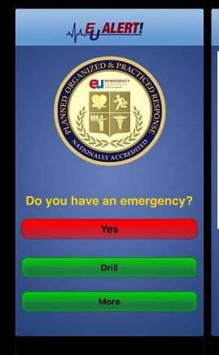
Figure ‎2-1 This is interface of EUalert app

Asafny app
Asafni is one of the digital solutions launched by the Saudi Red Crescent Authority in 2018 to enhance emergency and ambulance services in the Kingdom. The app aims to facilitate the process of uploading ambulance reports directly to the operating rooms, with the option to accurately geolocate and send basic medical data about the user such as chronic diseases and medications used , The application is also characterized by its support for people with special needs such as the deaf and hard of hearing, as it allows the possibility of sending reports without the need for voice communication, in addition to providing a multilingual interface to meet the needs of diverse populations. [6]
Disadvantages:
- technical challenges such as difficulty registering at times or the app failing to confirm codes,
-issues with location accuracy or connection stability in some regions.
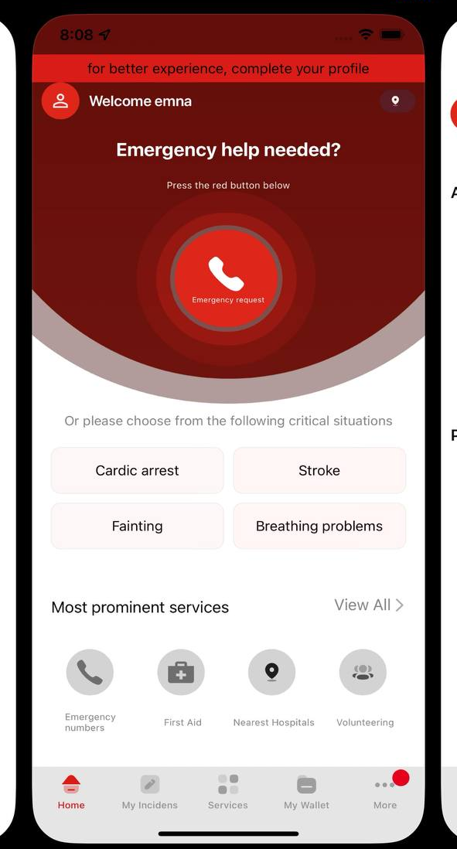
Figure ‎2-2 This is interface of Asafny app

Tables
SAFE | EUalert | Asafny | Name of app:
Provide a mobile tool for reporting medical emergencies, enabling quick communication, location sharing, and first aid guidance. | Enabling organizations to manage emergencies within buildings and connect trained responders to the incident immediately. | Facilitating the submission of medical emergency reports in the Kingdom and linking them to the Saudi Red Crescent, while supporting people with special needs. | Main Goals:
Android users in the Philippines for medical emergencies. | Institutional for institutional clients only | General within the Kingdom of Saudi Arabia for all citizens and residents | Scope of use:
Fast communication, GPS location, user-friendly interface. | Rapid response within the organization, training and awareness of responders, covering multiple emergencies | Support for people with special needs, multilingual, documenting reports, available to citizens and residents | Advantage:
Android only, Philippines only, requires internet, relies on user knowledge. | Dedicated to institutional clients only, Depends on availability of trained responders, Accurate location within buildings | Technical problems in registering or updating websites, depends on the Internet connection | Disadvantage:
Table ‎2-1 This is the summary of emergency response application
This table provides a summary of applications like ours, highlighting the advantages and disadvantages of each.

Research Gap
Our app:
provides immediate and accurate response to medical emergencies, accessible to everyone through an easy-to-use interface while ensuring user data protection. It offers quick and effective emergency response, eliminating the need to rely on specific responders, although improvements are needed to address the current reliance on limited responders within certain environments

FEASIBILITY STUDY
A feasibility study is a preliminary systematic evaluation aimed at determining the viability and potential success of a proposed project or new business venture. It involves analyzing risks, benefits, costs, challenges, timelines, budgeting, market research, supply chain factors, technological considerations, and legal requirements to enable stakeholders to make informed decisions on whether to pursue, modify, or abandon the project. The study typically concludes with a feasibility report that presents the findings and outlines the overall viability and implementability of the project. [7]

Purpose of the Feasibility Study
The purpose of this feasibility study is to determine whether the proposed system—Smart Health Response Application for Assisting Injured Individuals, a mobile application designed to provide rapid medical response during emergencies in public places—is practical and achievable. The study aims to evaluate the project from different aspects, such as technical feasibility, operational feasibility, and overall usability, in order to understand how easy and effective the system will be to implement and use.

Justification for the proposed system
1.Operational Purpose:
To create an integrated system that reduces the time between the moment of emergency and the arrival of life-saving medical care to the injured person.

2.Marketing Purpose:
Strategic partnership with official authorities: Cooperation with the Ministry of Health, the Red Crescent lends enormous credibility to the application and facilitates it to a wide segment of the public through the channels of these entities.

3.Scalability and Sustainability:
Geographical Expansion: The project can be started in one city as a pilot phase, then easily expand to other cities and regions, and finally cover the entire country or even other Arab countries.

Economic Feasibility
Economic feasibility is the assessment of whether a proposed project or investment is financially viable. It involves analyzing the costs, revenues, potential savings, and long-term financial impacts to determine if the expected benefits outweigh the expenses. This analysis helps decision-makers evaluate the profitability, sustainability, and overall economic justification of a project before committing resources.[8]

The development and implementation of our system will involve costs related to hardware, software development, server hosting, and maintenance. Utilizing open-source technologies and tools like Flutter for app development, Firebase for backend services, and Figma for UI/UX design can significantly reduce the software costs. So, our project is feasible economically.

Technical Feasibility
Definition:
Technical feasibility evaluates if the project can be developed and
implemented with available technology, resources, and expertise.
Technology Required:
Frontend: Flutter (cross-platform mobile development, responsive
UI, hot-reload)
Backend: Firebase (real-time database, user authentication, cloud
messaging, encrypted data)
Design Tools: Figma (UI/UX design, wireframes, prototyping)
Hardware Requirements:
Android and iOS smartphones
Internet connectivity (for real-time updates and notifications)
Firebase cloud services (no physical servers needed)
Feasibility Assessment:
All tools and platforms are available and accessible
Flutter supports cross-platform development
Firebase provides efficient backend and real-time communication
Figma allows collaborative and consistent UI design

Desired System Functionality
The key functionalities of the application will include:
- ‏User Registration and Authentication:
Allow users to securely create accounts, log in, and manage their profiles within the system.
- ‏Emergency Assistance Request:
Enable users to request medical assistance anytime and anywhere with automatic location detection to ensure accurate response.
- ‏Volunteer Response and Navigation:
Allow volunteers to view nearby emergency cases and navigate directly to the injured person using the integrated map feature.
- ‏First Aid Guidance:
Provide clear and interactive first aid instructions through videos, audio clips, and images to assist volunteers without prior medical training.
- Personal Health Profile:
Enable users to create and maintain a health profile that includes vital medical information such as blood type, chronic conditions, medications, and emergency contacts.
- ‏Enhanced Response Time:
Reduce response time by providing instant alerts and accurate location sharing between users and volunteers.
- ‏Public Awareness and Education:
Offer educational content (videos, texts, and audio materials) to raise public awareness about first aid and emergency procedures.
- ‏User-Friendly Interface:
Provide a simple, intuitive, and accessible interface designed for quick interaction during emergency situations.
- Administrative Management and Reporting:
Allow the administrator to monitor system activities, manage users and volunteers, document incidents, and generate analytical reports to evaluate and improve system performance.

PROJECT PLAN
Project planning is the process of defining the goals, timeline, tasks, resources and strategy for executing a project. It outlines what needs to be done, when and by whom to achieve the project’s goals. Anyone involved in the project, from the project manager to team members, can reference the project plan at any stage of the project to better understand their roles and responsibilities. [9]

Work Breakdown Structure
A work breakdown structure (WBS) is a visual, hierarchical and deliverable-oriented deconstruction of a project. It is a helpful diagram for project managers because it allows them to break down their project scope and visualize all the tasks required to complete their projects.
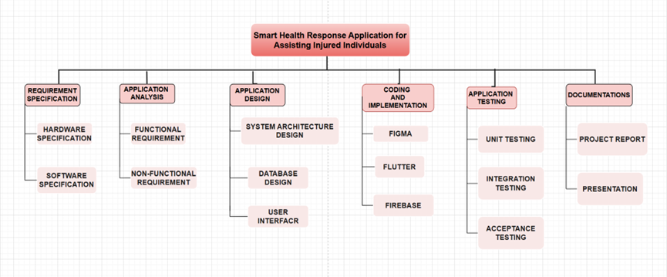
Figure ‎4-1 Work Breakdown Structure (WBS)
This diagram illustrates the project phases and the tasks of each phase.

Activity and Task List
An activity list is a document that outlines a set of organized activities or tasks related to a specific goal or area. It serves to clarify what needs to be done or what has already been completed. Activity lists are useful for planning, tracking progress and managing time and effort in various contexts such as work, education or personal projects.

Phase | Task | Duration | Start Date | End Date
Smart Health Response Application for Assisting Injured Individuals |  | 60 | 7/9/25 | 27/11/25
 |  | 12 | 7/9/25 | 22/9/25
Requirements Specification | Hardware Specification | 6 | 7/9/25 | 14/9/25
 | Software Specification | 6 | 15/9/25 | 22/9/25
 |  | 18 | 23/9/25 | 16/10/25
System Analysis | Functional Requirement | 9 | 23/9/25 | 5/10/25
 | Non-functional Requirement | 9 | 6/10/25 | 16/10/25
 |  | 30 | 19/10/25 | 27/11/25
System Design | System Architecture Design | 6 | 19/10/25 | 26/10/25
 | Database Design | 9 | 27/10/25 | 6/11/25
 | User Interface | 15 | 9/11/25 | 27/11/25
Table ‎4-1 Activity and Task list
Provides a breakdown of the project into main phases (Requirements Specification, System Analysis, System Design), listing tasks, durations (in days), and start/end dates.

Gantt Chart
A Gantt Chart serves as a project management tool designed to visually outline a project's schedule. It organizes tasks or activities along the vertical axis, while time is displayed on the horizontal axis. Horizontal bars represent each task, illustrating their start date, end date, and duration.

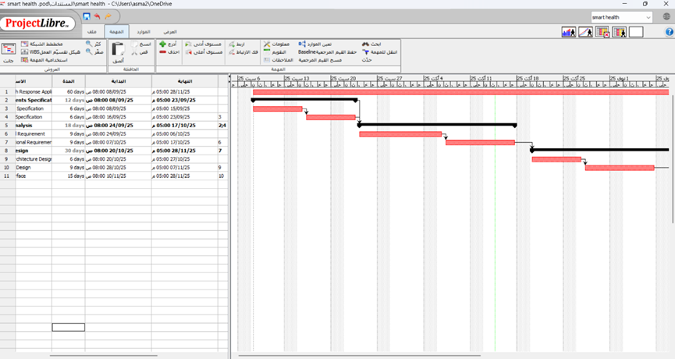
Figure ‎4-2 Gantt Chart
A visual representation of the project schedule, illustrating the timeline for tasks in horizontal bars using the ProjectLibre tool.

SRS – SYSTEM REQUIREMENTS SPECIFICATION
The Software Requirement Specification (SRS) format serves as a comprehensive outline and detailed explanation of the requirements needed for the software's successful development. These requirements encompass both functional and non-functional aspects, based on the specific needs of the project. Effective communication between customers and contractors is essential to ensure a clear understanding of customer expectations and necessities.[10]

Development Methodology
A software development methodology is a framework used to structure, plan, and manage the software development process. Its goal is to ensure the delivery of software in accordance with project specifications, within time and budget, and with minimized project risks.[11]

5.1.1 Waterfall Methodology
The Waterfall methodology is a linear and sequential project management approach in which each phase, from analysis and design to development and testing, is completed before the next phase begins. This methodology emphasizes careful upfront planning, detailed documentation, and structured execution to ensure clear requirements, predictable timelines, and measurable progress.[12]
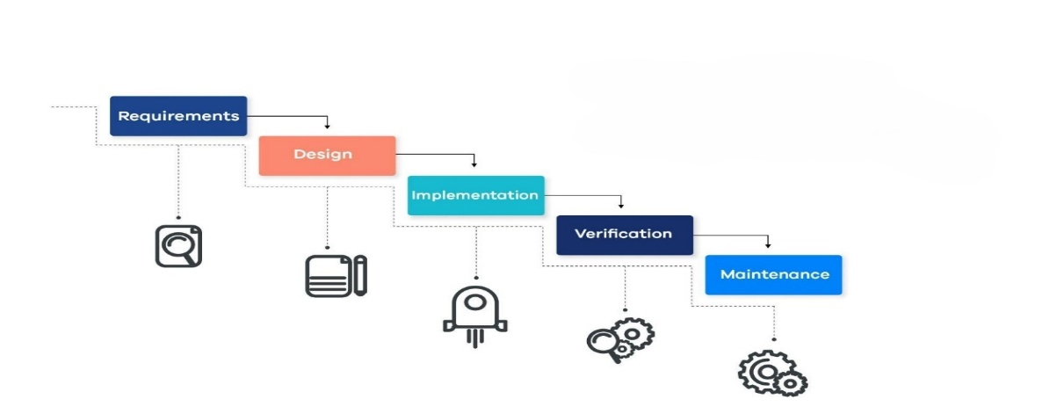
Figure 5-1 Waterfall Methodology

Waterfall Methodology Phases
- Requirements:
Identifying and understanding all project requirements upfront to create a clear document including costs, risks, assumptions, and timelines.
- Design:
Creating a technical design for the project, including high-level structure and detailed low-level components.
- Implementation:
Writing the code and implementing the application based on the design and requirements, with some initial testing.
- Verification:
Testing the product to ensure it is error-free and all requirements are met.
- Maintenance:
Releasing the product to the end user and performing updates and maintenance based on feedback and change requests.[12]

System Requirements Analysis
Application Requirements Analysis is a crucial phase in software development. It involves identifying, documenting, and analyzing all the functional and non-functional requirements needed for the mobile application to operate effectively and meet user needs.

5.2.1 Functional Requirements:
- Admin: A system administrator who manages users, monitors reports, and maintains overall system performance.
- Login: Access the secure web-based admin control panel.
- Manage Users: Add, edit, or deactivate reporters, responders, and facilities.
- Approve Responders: Verify and activate responders after reviewing certifications.
- Monitor System Activity: View active incidents on a live Jazan map.
- Manage Facilities & AEDs: Update hospitals, clinics, and AED device locations.
- System Maintenance: Monitor server health and data synchronization.
- Data Management: Manage backups, data retention, and restoration.
- Generate & Schedule Reports: Create and send automated analytical reports.
- Export & Share Data: Download reports in PDF or Excel format.
- Audit Logs: Review all system actions and user activities.
- Broadcast Emergency Alerts: Send urgent notifications to responders in specific regions.

- Reporter: A user who reports medical emergencies through the application by sending alerts with location details.
- Registration: Create an account using a phone number or email.
- Login: Access the emergency dashboard after authentication.
- Send Emergency Alert (SOS): Report emergencies instantly with GPS location and case type.
- Voice-Activated SOS: Trigger an alert by voice command when unable to use the phone.
- Attach Media: Upload photos or voice notes to describe the situation.
- Offline First Aid Guidance: Follow CPR or first-aid steps without an internet connection.
- Share Live Location: Allow continuous tracking of the user’s real-time position.
- Emergency Contact Alert: Automatically notify a saved contact once an alert is sent.
- View ETA: Display the responder’s estimated arrival time on the map.
- In-App Communication: Chat or call securely with the responder or dispatcher.
- Track Report Status: Monitor case progress from received to closed.
- Rate Service: Evaluate and provide feedback after the case is completed.
- Logout: Securely exit their account.

- Responder: A trained individual who provides first aid and responds to emergency alerts in the field.
- Registration: Register as a responder and upload CPR or first-aid certificates.
- Login: Access the responder dashboard and manage availability.
- Receive Nearby Alerts: Get instant notifications for nearby emergencies.
- Accept or Reject Alert: Respond to or decline cases with a given reason.
- Smart Assignment: Automatically assign cases based on distance and qualification.
- Navigation & Live Location: Use map navigation while sharing real-time tracking.
- Medical Protocol Guidance: View case-based instructions (CPR, bleeding, choking, etc.).
- In-App Communication: Communicate with reporter and hospital during the case.
- Handover Report: Complete a short form when transferring the patient.
- Close Case: Submit the final report and mark the case as completed.
- Logout: Securely exit their account.

- Receiving Facility: A hospital or medical center that receives patients and confirms case completion in the system.
- Login: Access the facility dashboard to view active and incoming cases.
- View Incoming Alerts: Receive notifications for patients being transferred.
- Track Responder Location: Monitor live route and estimated arrival time (ETA).
- Communicate with Responder: Exchange quick updates such as “ER ready” or “Use Gate 2.”
- Confirm Case Reception: Verify that the patient has arrived at the facility.
- Fill Handover Form: Record patient details and receiving staff information.
- Update Case Status: Change status to “Received,” “In Treatment,” or “Closed.”
- Generate Internal Reports: View statistics of received cases by date or type.
- Feedback to System: Provide outcome notes to improve response quality.

5.2.2 Non-Functional Requirements:

- Performance:
- Response Time: Send and process alerts within 3 seconds.
- Network Efficiency: Operate smoothly even with weak connections.

- Security:
- Data Encryption: Protect user and medical data at all times.
- User Authentication: Apply strong authentication measures.
- Access Control: Limit data access based on user roles.

- Reliability:
- High Availability: Maintain 99.9% uptime for continuous service.
- Error Recovery: Automatically recover from failures or interruptions.

- Usability:
- Ease of Use: Provide a simple and intuitive interface for quick actions.
- Accessibility: Ensure clear visuals and easy navigation under pressure.

- Availability:
- 24/7 Operation: Ensure access to the system at any time.

- Maintainability:
- Modular Design: Allow easy updates, fixes, and feature upgrades.
- Error Logs: Record system events for quick troubleshooting.
- Continuous Updates: Enable improvements without service disruption.

- Compatibility:
- Cross-Platform: Support Android and iOS devices seamlessly.
- System Integration: Connect with hospitals and emergency systems.

Hardware Requirements Specification

Item | Description
Phone (Client) | Latest flagship device (e.g., Samsung Galaxy S-series, Apple iPhone Pro)
Processor | 3.2 GHz or higher
RAM | 4 GB or higher
Hard Disk | 32GB or higher
OS | Android 14 or higher, or iOS 17 or higher
Table 5-1 Hardware Requirement Specifications

Software Requirement Specification

Description | Item
Frontend (Cross-platform mobile development with responsive UI and hot-reload) | Flutter
Design Tools: (UI/UX design, wireframes, prototyping) | Figma
Program for creating UML diagrams | Draw.io
For writing reports | MS Word
Backend (real-time database, user authentication, cloud messaging, encrypted data) | Firebase
Table 5-2 Software Requirements Specifications

Flutter:
Open-source framework from Google for building mobile, desktop, and web apps by writing code just once.
Key features:
Beautiful and fast user interface: it uses a technology called "Skia" to make apps smooth and engaging
Language used: Dart.


Figure 5-2 Flutter
Figma:
A cloud-based (browser-based) tool for designing user interfaces (UIs), user experiences (UXs), and creating interactive prototypes.
Key Features:
Real-Time Collaboration: Multiple designers work on the same file simultaneously (like Google Docs).
No Installation Required: Works directly from the browser.
Interactive Prototyping: You can link screens together to preview how your app or website will work before coding.
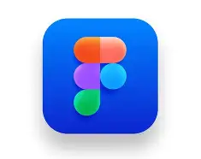
Figure 5-3 Figma
Draw.io:
Is a free, web-based diagramming tool used for creating flowcharts, network diagrams, organizational charts, and other types of visual representations. It allows users to create and edit diagrams using drag-and-drop features, with various shapes, connectors, and templates. Draw.io supports collaboration, integrates with cloud storage services like Google Drive, and is commonly used for both personal and professional diagramming needs.

Figure 5-4 Draw.io

MS Word:
Microsoft Word (MS Word) is a word processing software developed by Microsoft. It is used for creating, editing, formatting, and printing text documents. MS Word offers a wide range of features such as text formatting, spell check, templates, images, tables, and collaboration tools, making it suitable for writing reports, letters, essays, and other types of documents.

Figure 5-5 MS word

Other Requirements Specification

Database
A database is an organized and structured collection of related and structured information, or data, that is electronically stored and managed by a Database Management System (DBMS). It enables the efficient storage, retrieval, modification, and control of data—including text, numbers, images, and videos—while maintaining integrity, security, and allowing concurrent access by multiple users or applications. Databases are fundamental to modern information systems, supporting a wide range of tasks such as managing customer transactions, product inventory, financial records, and large-scale enterprise analytics.

Firebase
Firebase is a comprehensive Backend-as-a-Service (BaaS) platform developed by Google that provides a wide range of cloud-based tools and services designed to help developers build, deploy, and manage high-quality web and mobile applications efficiently. It eliminates the need for developers to create and maintain backend infrastructure from scratch, allowing them to focus on application logic and user experience and widely used because of its ease of integration, real-time synchronization, cross-platform support, and tight integration with Google Cloud services. It supports frameworks like React, Angular, Flutter, and Android SDK, making it suitable for modern application development.


Figure 5-6 Firebase

SYSTEM DESIGN

Applications Architecture Design
Application Architecture Design is the fundamental blueprint that defines the structure and direction for developing and maintaining applications within an organization. It ensures alignment with business objectives, efficiency, and reliability while considering factors such as scalability, maintainability, and performance to drive business success.[13]

6.1.1 Three Tier Architecture
Three-tier architecture is a well-established software application architecture that organizes applications into three logical and physical computing tiers: the presentation tier, or user interface; the application tier, where data is processed; and the data tier, where application data is stored and managed.[14]
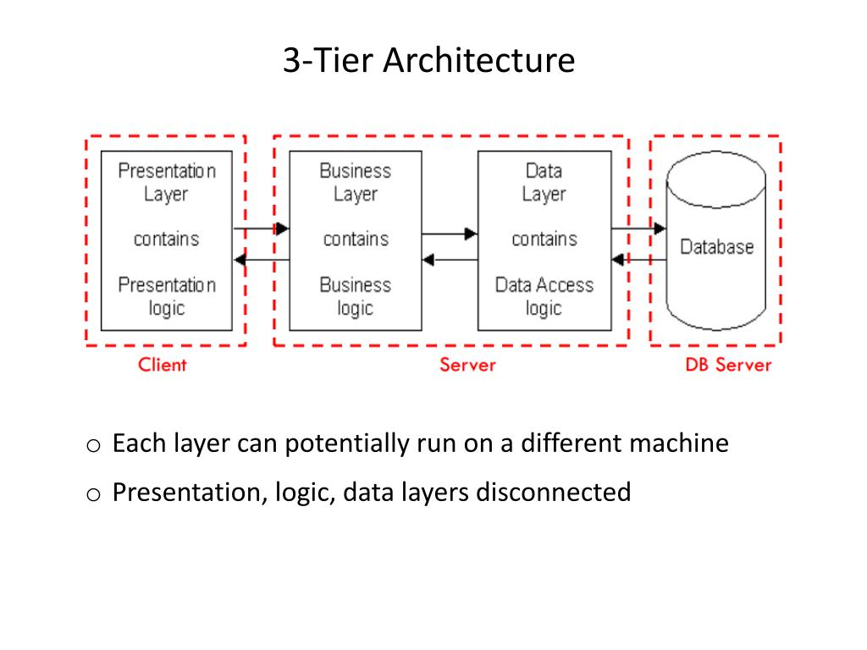
Figure 6-1 Three tier architecture

Presentation Tire
The presentation tier is the user interface and communication layer of the application, where the end user interacts with the application. Its main purpose is to display information to and collect information from the user. This top-level tier can run on a web browser, as desktop application, or a graphical user interface (GUI), for example. Web presentation tiers are developed by using HTML, CSS, and JavaScript. Desktop applications can be written in various languages depending on the platform.

Application Tire
The application tier, also known as the logic or middle tier, serves as the application's core. Here, data gathered by the presentation tier is processed according to specific business rules. This processing may involve retrieving, comparing, or modifying information stored in the data tier. The application tier is commonly built using languages like Python, Java, PHP, or Ruby, and communicates with the data tier through API calls.

Data Tire

The data tier, often called the database tier or back-end, is where the application's information is stored and managed. This tier typically consists of a relational database management system (e.g., PostgreSQL, MySQL, Oracle, Microsoft SQL Server) or a NoSQL database server (e.g., MongoDB, Cassandra, CouchDB).

Models

6.2.1 Use Case Diagram
In the Unified Modeling Language (UML), a use case diagram can summarize the details of your system's users (also known as actors) and their interactions with the system. To build one, you'll use a set of specialized symbols and connectors.[15]
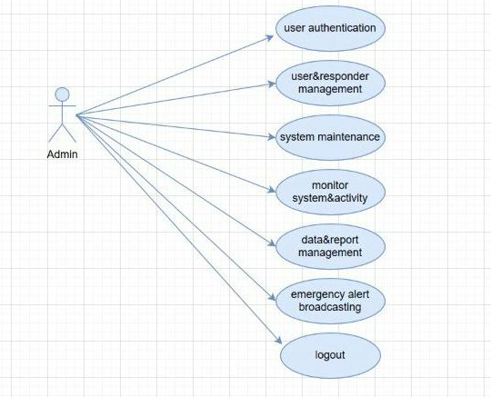
Figure 6-2 Use case diagram for admin
The Use Case diagram illustrates the basic tasks of the system admin and their management of key functions.

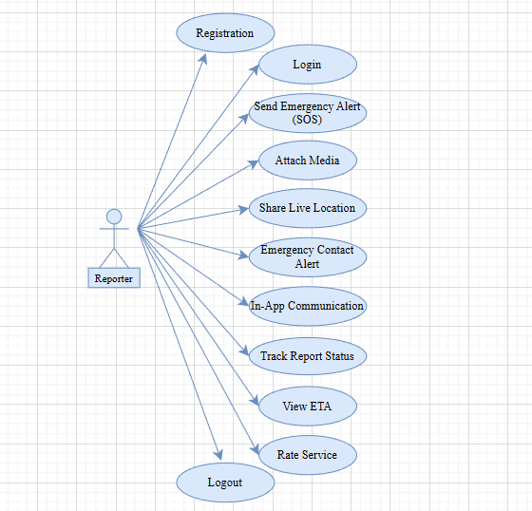
Figure 6-3 Use case diagram for Reporter
This diagram shows how the Reporter interacts with the system to report incidents and communicate during emergencies. It illustrates the Reporter’s basic role in using the system.

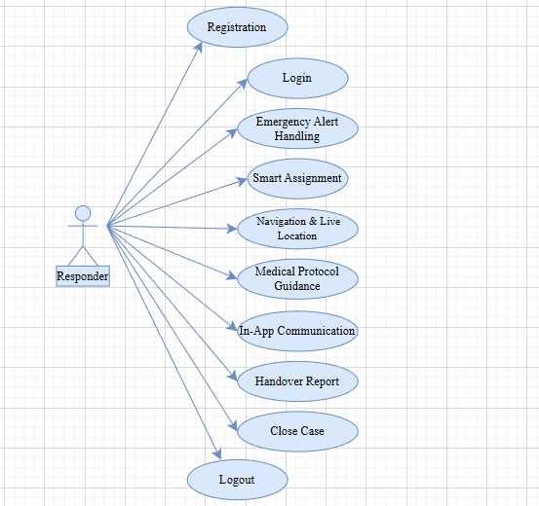
Figure 6-4 Use case diagram for Responder
This diagram shows how the Responder interacts with the system to handle reported incidents. It illustrates the Responder’s role in responding to emergencies using the system.
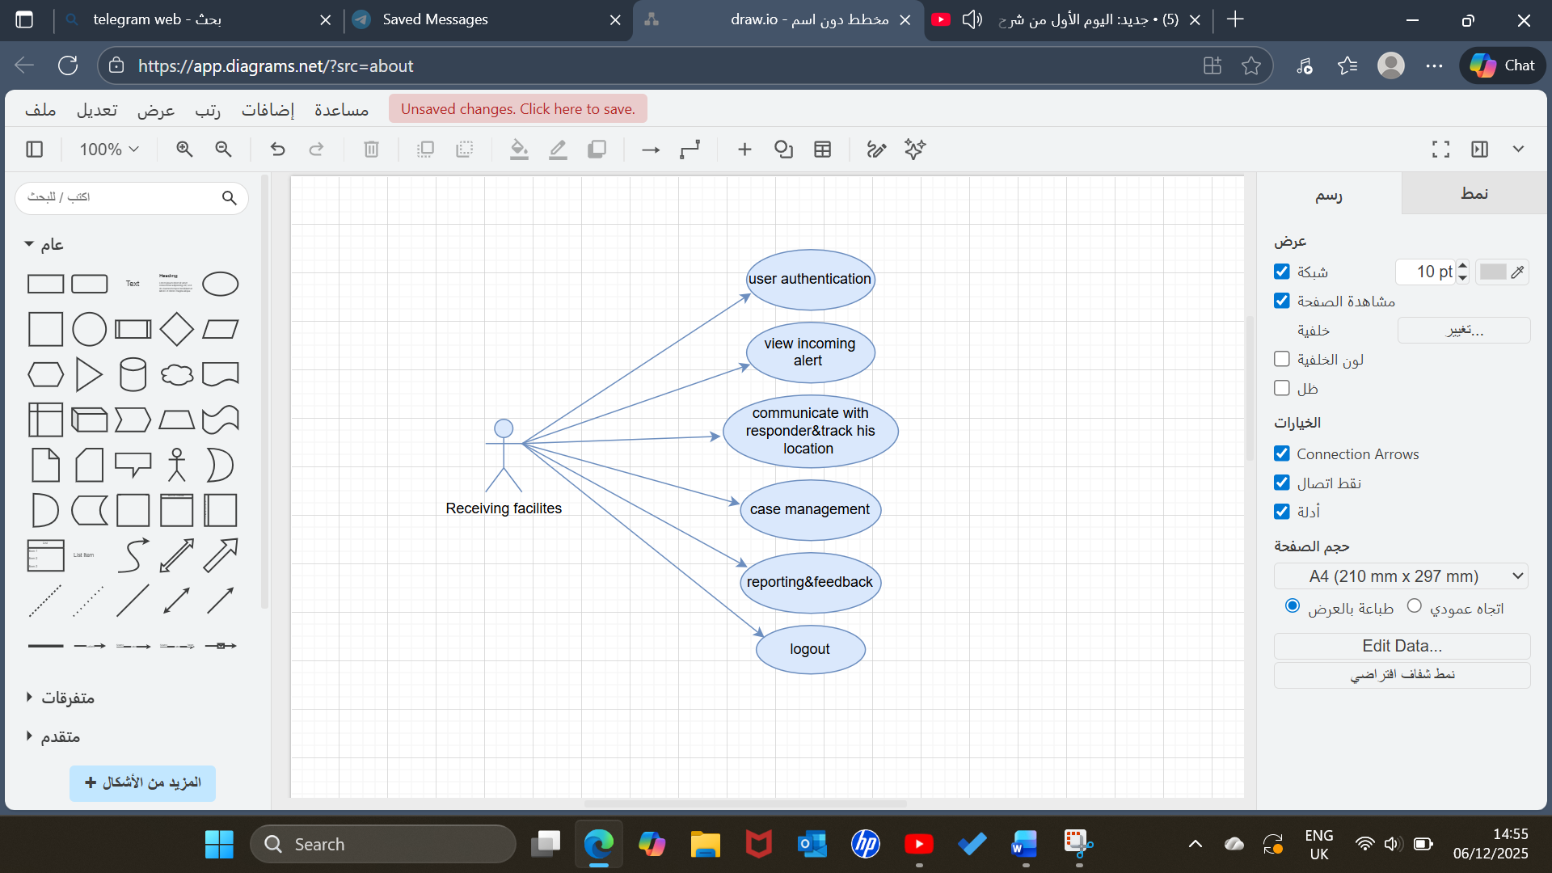
Figure 6-5 Use case diagram for receiving facilites
This Use Case diagram for the receiving facilities, highlights their main interactions with the system.

6.2.2 Data Flow Diagram (DFD)

A Data Flow Diagram (DFD) is a graphical representation that illustrates how data moves through an information system, showing the relationship between processes, data stores, data flows, and external entities. It is one of the most used tools in systems analysis and design, helping analysts, designers, and users visualize the logic of data movement and processing without focusing on technical details such as programming or hardware.[16]

DFD Level 0 (Context Level)
A Level 0 Data Flow Diagram (DFD) also known as a Context Diagram, is a high-level graphical representation that illustrates the entire system as a single process and shows how it interacts with external entities such as users, organizations, or other systems through the flow of data. It defines the system’s boundaries by depicting what data enters the system (inputs) and what data leaves the system (outputs), without showing internal processes or data stores.

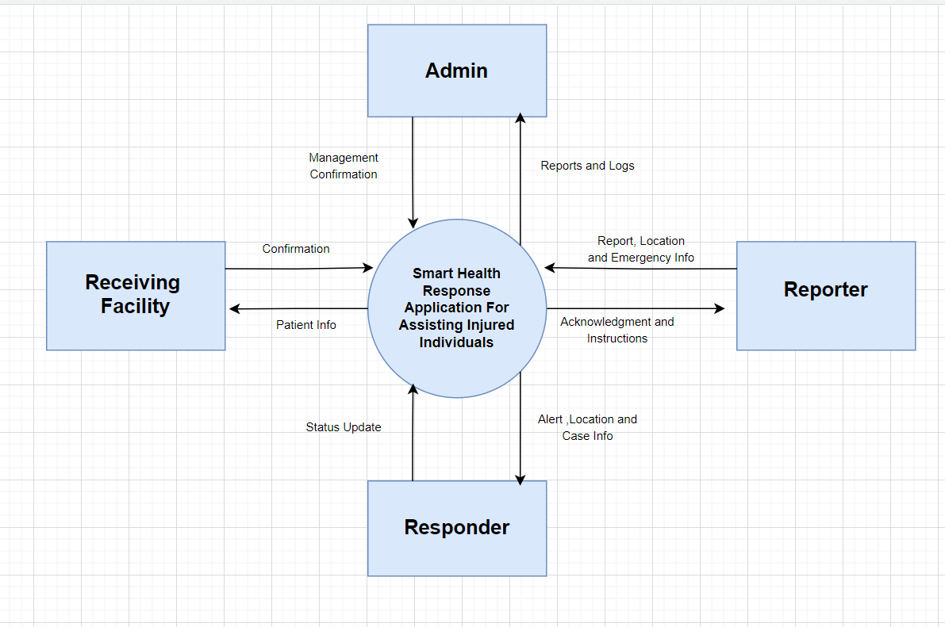
Figure 6-6 DFD Level 0 (Context Level)
This diagram shows the system as one main process and illustrates how it exchanges data with external entities such as Admin, Reporter, Responder, and Receiving Facility.

DFD Level 1
Data Flow Diagram (DFD) offers a more detailed representation of the primary system process by dividing it into multiple sub-processes. It illustrates the internal data movement between these sub-processes and highlights how the system engages with external entities like users, staff, and administrators. At this level, the diagram pinpoints data stores, outlines internal workflows, and explains the role of each system component in achieving overall functionality.
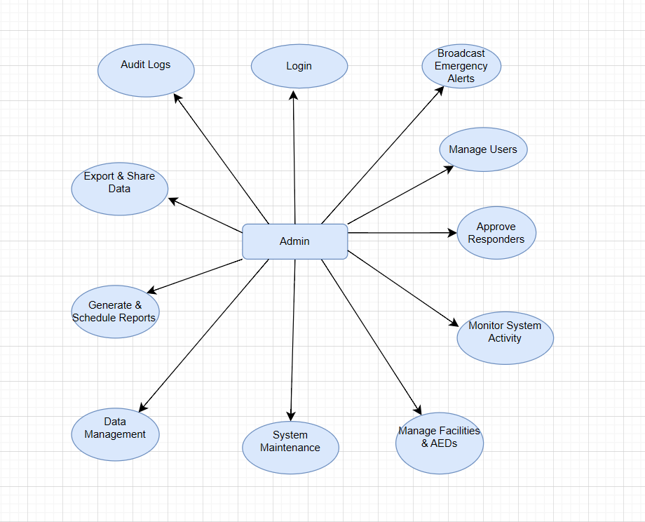
Figure 6-7 DFD-level-1 for admin
This diagram illustrates the role of the Admin user in the system. The Admin is responsible for managing users and overseeing system operations. They monitor system activity, handle data and reports, and perform system maintenance. Additionally, the Admin manages emergency alerts when needed.

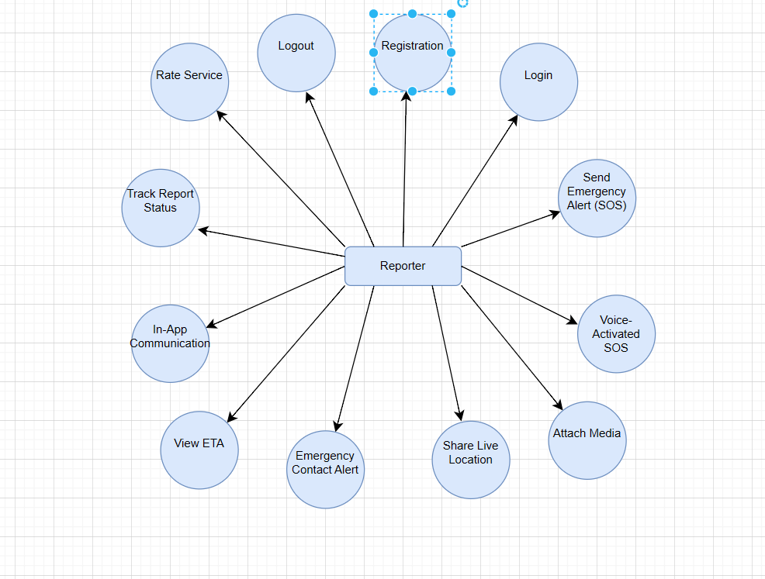
Figure 6-8-DFD level 1 for reporter
This diagram shows the role of the Reporter user. The Reporter registers and logs into the system to report emergencies. They can send emergency alerts, share their location, and attach media to support the report. The Reporter can also track the status of submitted cases.
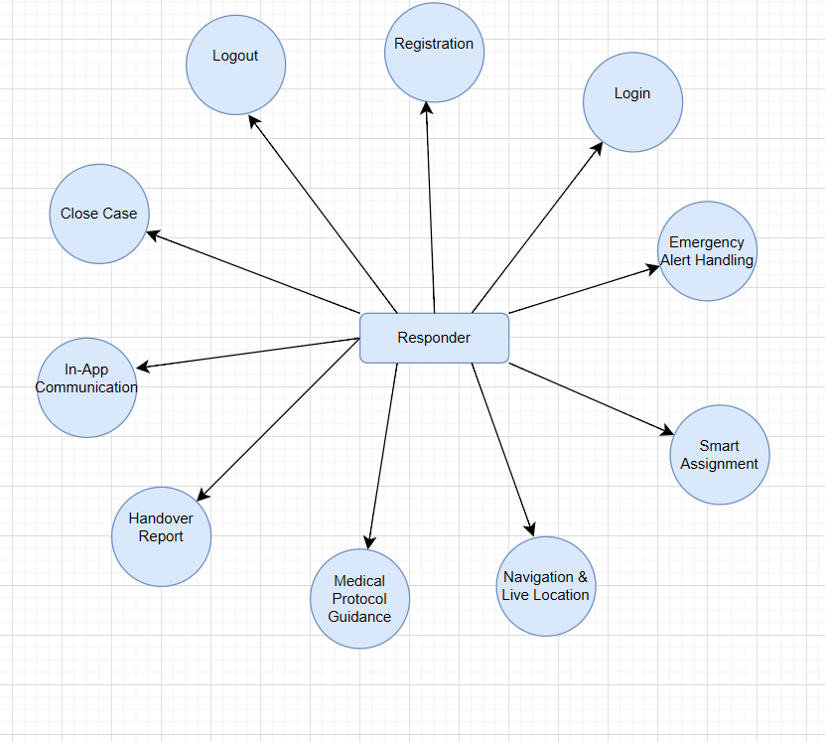
Figure 6-9 DFD level 1 for responder
This diagram presents the role of the Responder user. The Responder receives and handles emergency cases, navigates to the incident location, and follows medical guidance. After completing the response, the Responder closes the case to finalize the process.

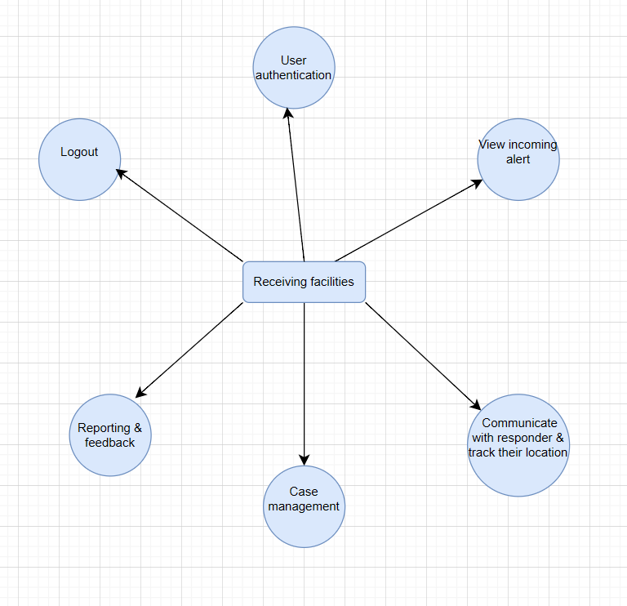
Figure 6-10 DFD-level-1 for receiving facilities
A Level 1 Data Flow Diagram (DFD) showing the main functions of receiving facilities in the system.

6.2.3 Activity diagram
An Activity Diagram is a type of UML behavioral diagram that illustrates the flow of activities within a system. It outlines how a process starts, the actions carried out, the decision points faced, and how the process concludes. This diagram provides a clear and structured representation of the sequence of steps, parallel processes, and user interactions. It is widely used to analyze system behavior, enhance workflow understanding, and confirm that all functional steps have been accurately outlined.

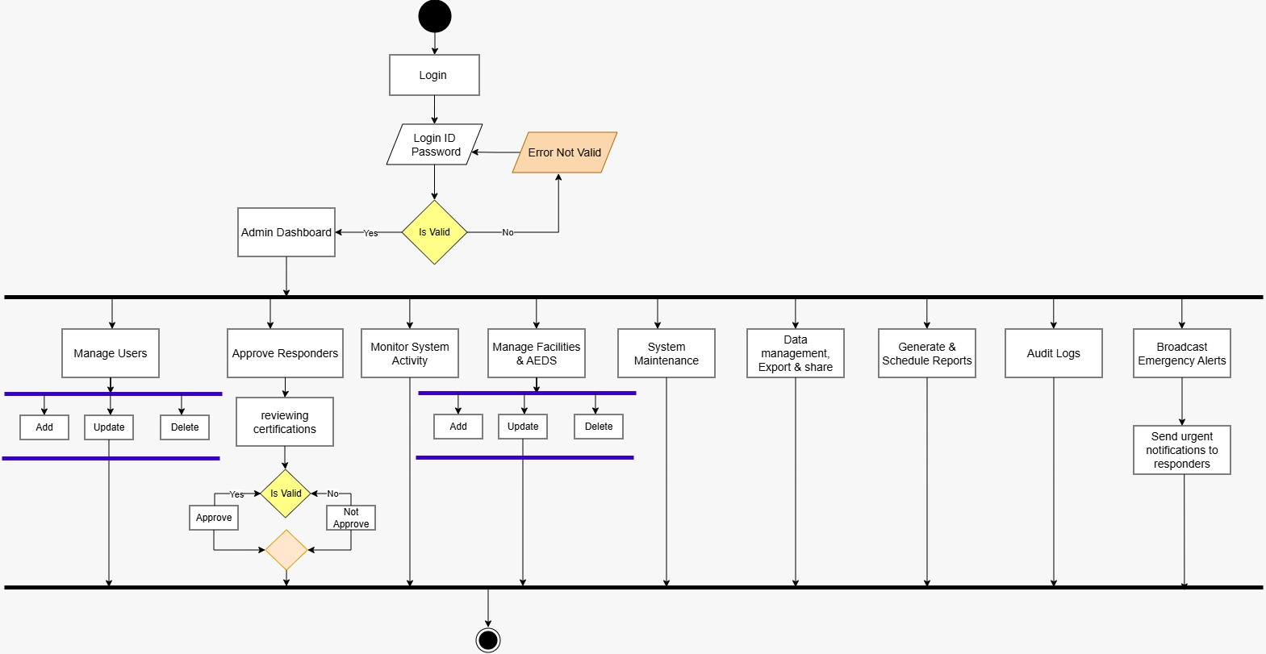
Figure 6-11 Activity Diagram for Admin
The Admin logs in to manage users, approve responders, maintain facilities, generate reports, and broadcast emergency alerts.

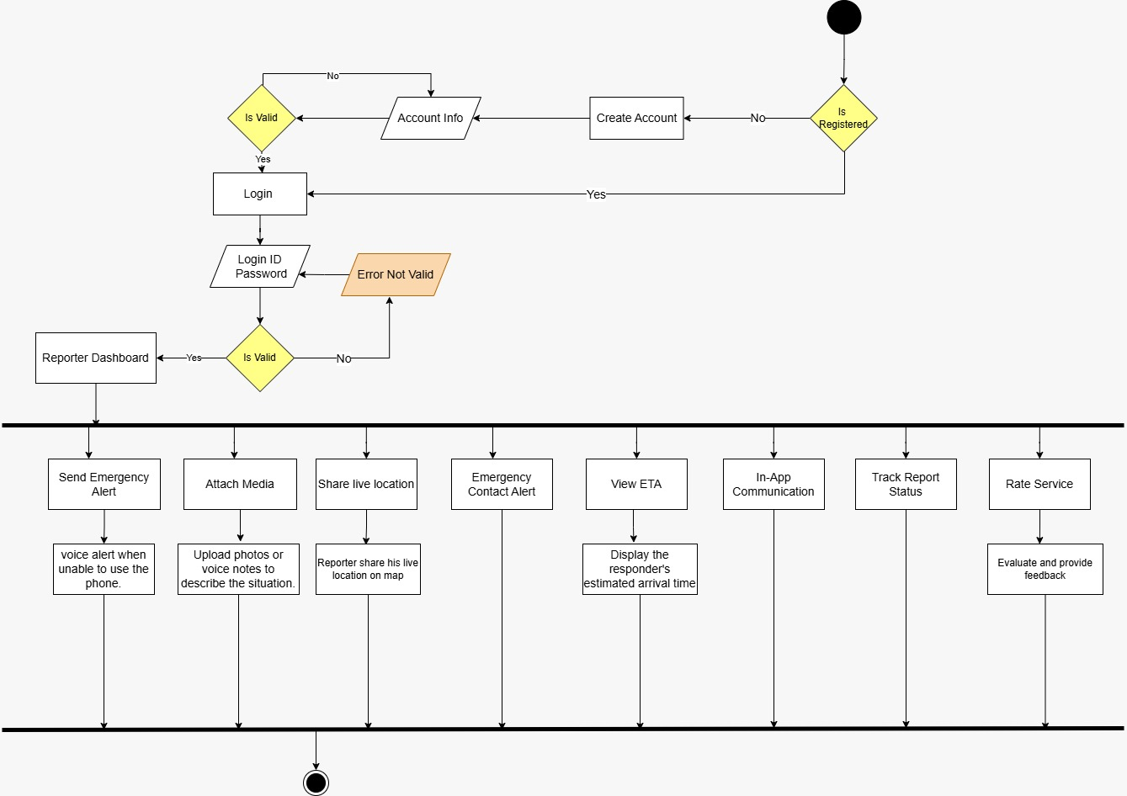
Figure 6-12 Activity Diagram for Reporter
The Reporter signs up or logs in to the dashboard to send emergency alerts, share location, attach media, track status, and rate the service.
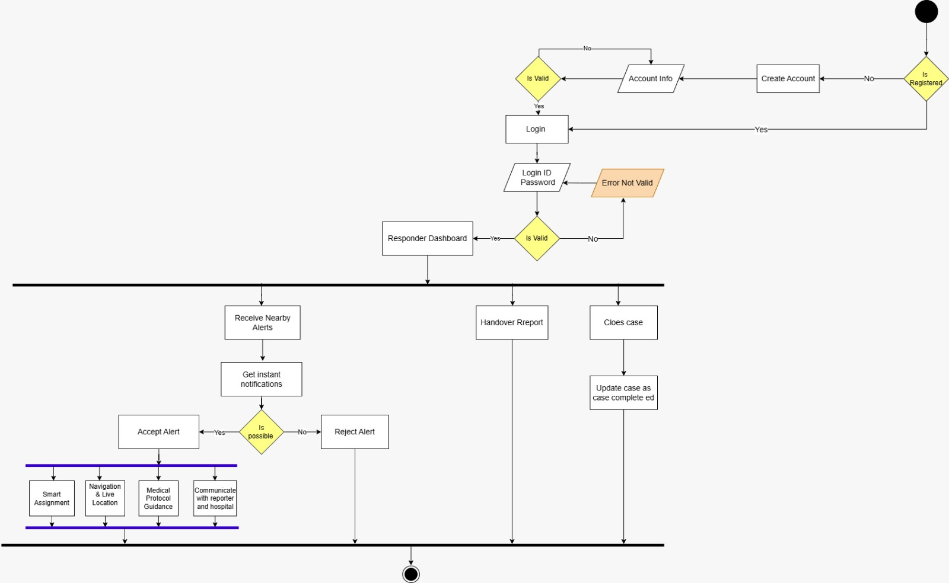
Figure 6-13 Activity Diagram for Responder
The Responder logs in to receive and accept/reject nearby alerts, navigate to the incident, and then hand over or close the case.

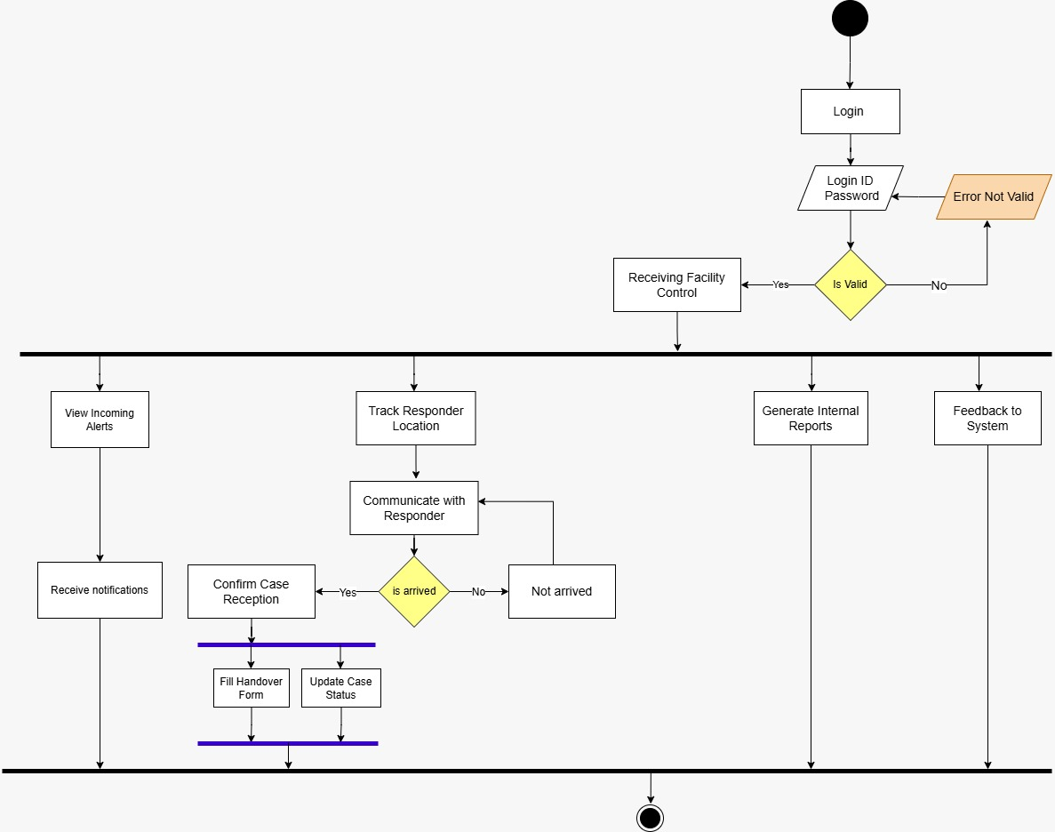
Figure 6-14 Activity Diagram for Receiving Facility
The Facility logs in to view incoming alerts, track the responder's location, communicate with them, and update the case status upon arrival.

6.2.4 Sequence Diagram
A UML sequence diagram is a graphical representation that shows how objects in a system interact over time. It captures the sequence of messages exchanged between objects and the order of these interactions, using vertical lifelines and horizontal arrows. In essence, it provides a chronological view of object interactions and offers insights into the system’s dynamic behavior and flow.[17]
This visualization is essential in software and system design because it improves clarity, collaboration, and understanding. A sequence diagram serves as a visual playbook that ensures all stakeholders share a clear view of system behavior, supporting accurate development, troubleshooting, modification, and teamwork.[17]
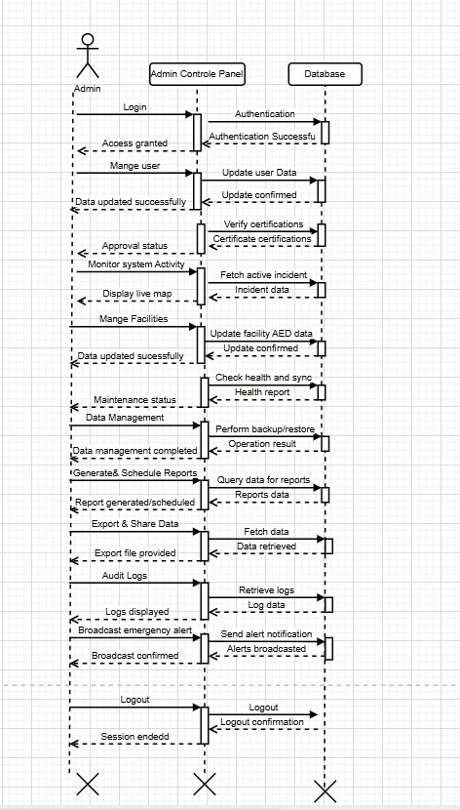
Figure 6-15 Sequence diagram for admin
A sequence diagram illustrating the interaction between the admin, the control panel, and the database for system management.

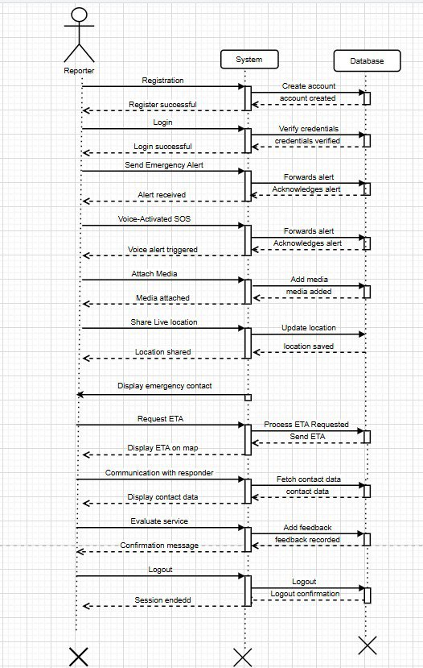
Figure 6-16 Sequence diagram for reporter
A sequence diagram showing the interaction between the reporter, the system, and the database during emergency reporting.

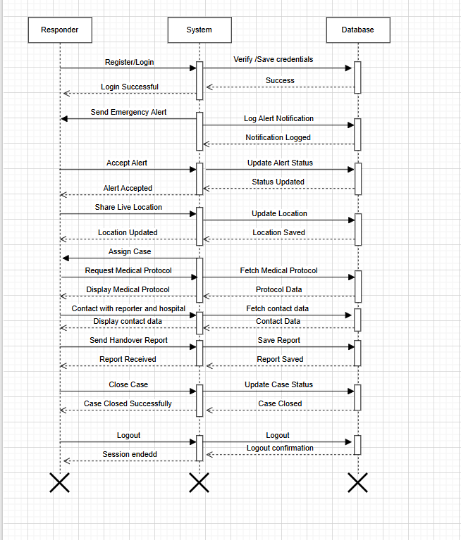
Figure 6-17 Sequence diagram for responder
This diagram Illustrates the responder's interaction with the system from login to case closure and logout.

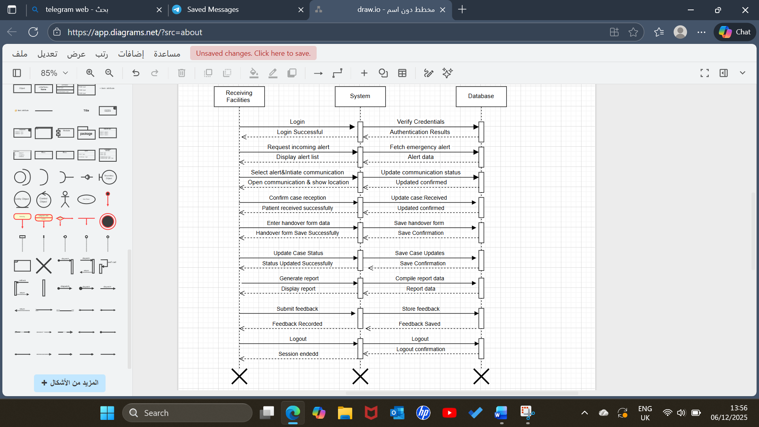
Figure 6-18 Sequence diagram for receiving facilities
This diagram Illustrates the receiver's interaction with the system from receiving the report to case closure and logout.

6.2.5 Class Diagram
A class diagram describes the static structure of a system, consisting of a set of classes and the relationships defined between them. A class provides the description of a group of objects and specifies their attributes and operations, thereby forming the fundamental building blocks for representing the structural aspects of a model.[18]

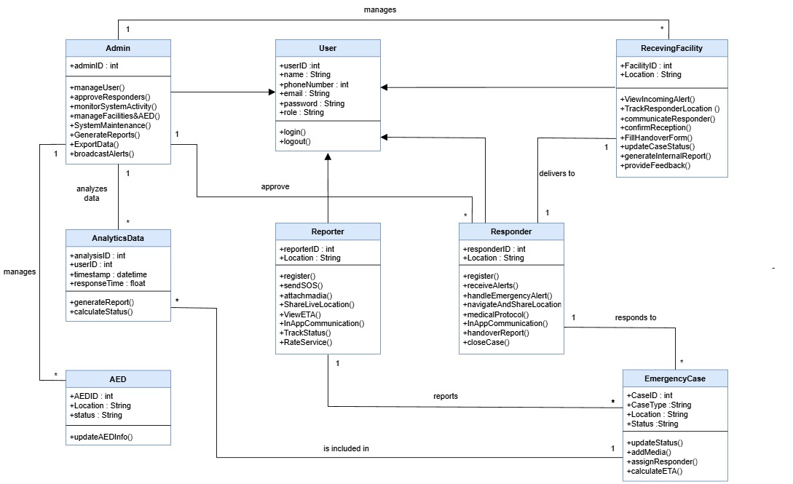
Figure 6-19 Class diagram
This class diagram illustrates the main classes of the smart health response application for assisting injured individuals, including Admin, User, Reporter, Responder, EmergencyCase, ReceivingFacility, AED, and AnalyticsData.
It shows how these classes interact with each other to support emergency reporting, response handling, system management, and data analysis.

6.2.6 Entity Relationship Diagram (ERD)
An Entity–Relationship Diagram (ERD) is a graphical model used during database design to illustrate how data is structured, organized, and connected within a system. It gives a high-level conceptual view of the system’s entities, their attributes, and the relationships between them, which helps designers understand the system clearly before building the actual database.[19]
In an ERD:
1. Entities: are the object, person, event, or concept that you need to store data about
(e.g., "Customer" or "Order").
2. Attributes: is a detail or property that describes an entity (e.g., "Customer Name" or
"Order Date").
3. Relationships: describe how two entities are connected or interact with each other.
It becomes the basis for linking tables using keys (e.g., "Places" or
"Contains").
4. Cardinality: shows how many instances of one entity can be associated with another
) One-to-One، One-to-Many, Many-to-Many).

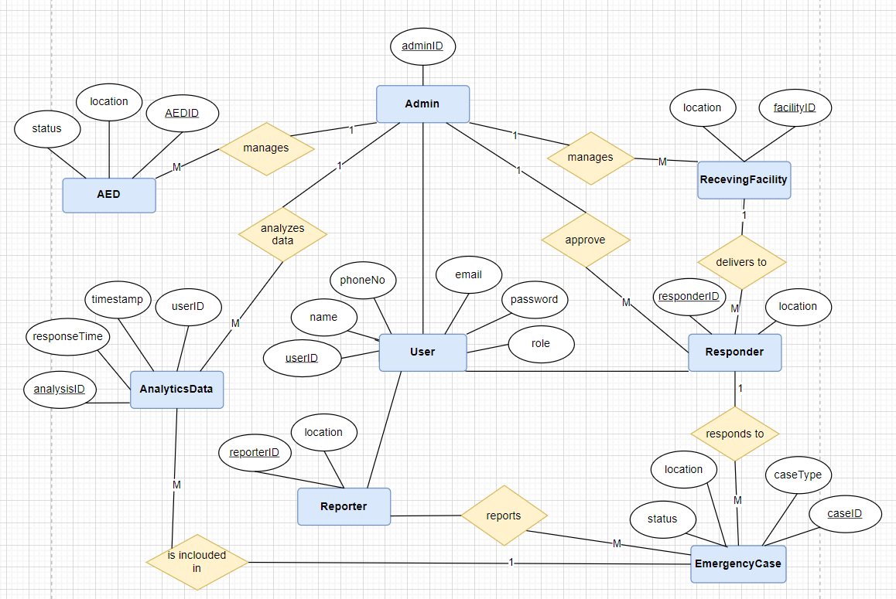
Figure 6-20 Entity relationship diagram (ERD)
This diagram illustrates the database structure by showing the main entities, their attributes, and the relationships between them.

CONCLUSION

The Smart Health Response Application for Assisting Injured Individuals provides an innovative solution to improve emergency medical response in public spaces. By connecting witnesses, volunteers, medical specialists, and official authorities in real time, the application reduces response times, delivers critical assistance promptly, and increases the chances of survival. It also empowers non-specialized individuals to provide accurate first aid under professional guidance and raises public awareness of emergency procedures. This project demonstrates how technology and community engagement can bridge gaps in current emergency systems, contributing to a safer, more responsive society and improving health outcomes during unexpected emergencies.

REFERENCES
- John Nicolo T. Cruz, G. A. (2021). SAFE: Smart Application for Emergency.
- Albahri, O. S., Zaidan, A. A., Zaidan, B. B., Khalaf, M., Alsalem, M., Albahri, A. S., … Saliu, A. A. (2020). A survey on smart emergency medical services (EMS): Challenges and future directions. Journal of Medical Systems, 208.
- Gabella, J. L., Gualda, I. A., Altoé, I. L., Beltrame, M. H., da Silva, P. H., Costa, D. B., … de Andrade, L. (2024). Designing, development and validation of an app to reduce the response time of the emergency medical services.
- Areej Alshutayria, N. A. (2021). An Interactive Mobile Application to Request the Help of the Nearest First Aider to the Injured. Advances in Distributed Computing and Artificial Intelligence Journal.
- Union, E. (2022, June 21). Emergency University. Retrieved from
https://www.emergencyuniversity.com/technology
- Authority, S. R. (2008, December 22). About the Authority. Retrieved from
https://srca.org.sa/
(Asafny system reference)
- DeMarco. (2025, May 3). What is a Feasibility Study? Benefits, Types, and Examples. Retrieved from Shopify:
https://www.shopify.com/blog/feasibility-study
- Jordi Gol-Montserrat, M. L. (2017, January–December). Analysis of Productivity Costs in Cancer: A Systematic Review. Retrieved from Global & Regional Health Technology Assessment:
https://journals.aboutscience.eu/index.php/grhta/article/view/384
- PM. (n.d.). ProjectManager. Retrieved from
https://www.projectmanager.com/guides/project-planning
- SRS. (n.d.). Software Requirement Specification (SRS) Format. Retrieved from
https://www.geeksforgeeks.org/software-engineering/software-requirement-specification-srs-format/
- Nikitin, V. (2024, April 16). Software development methodologies: Types, selection criteria & stages. Retrieved from Itransition:
https://www.itransition.com/software-development/methodologies
- Adobe. (n.d.). Waterfall project management methodology: The basics. Retrieved from Adobe Business:
https://business.adobe.com/blog/basics/waterfall
- Ardoq. (2024, December 13). What is application architecture? Ardoq. https://www.ardoq.com/knowledge-hub/application-architecture
- IBM. (n.d.). What is three-tier architecture? IBM. https://www.ibm.com/think/topics/three-tier-architectu
- GeeksforGeeks. (2025, July 23). Use case diagram – Unified Modeling Language (UML). GeeksforGeeks. https://www.geeksforgeeks.org/system-design/use-case-diagram/
- GeeksforGeeks. (2025, December 9). What is DFD (Data Flow Diagram). GeeksforGeeks. https://www.geeksforgeeks.org/software-engineering/what-is-dfddata-flow-diagram/
- Miro. (n.d.). What is a UML Sequence Diagram?. Retrieved from
https://miro.com/diagramming/what-is-a-uml-sequence-diagram/
- Breu, R., Hinkel, U., Hofmann, C., Klein, C., Paech, B., Rumpe, B., & Thurner, V. (1997). Towards a formalization of the Unified Modeling Language. In M. Aksit & S. Matsuoka (Eds.), Proceedings of ECOOP’97 – Object-Oriented Programming, 11th European Conference (Lecture Notes in Computer Science, Vol. 1241). Springer. https://www.se-rwth.de/publications
- NoobToMaster. (n.d.). Entity‑relationship diagrams (ERDs). NoobToMaster. https://noobtomaster.com/database-management-system/entity-relationship-diagrams-erds/

